

**NETWORKING & SYSTEM ADMINISTRATION LAB**

**Experiment No.: 5**

**Aim**

Familiarization of basic linux commands

**Procedure:**

1. **cut -d** - -d option is used then it consider space as a field separator or delimiter.

**syntax:**$ cut -d ‘ ‘ f1 samples

**output:**

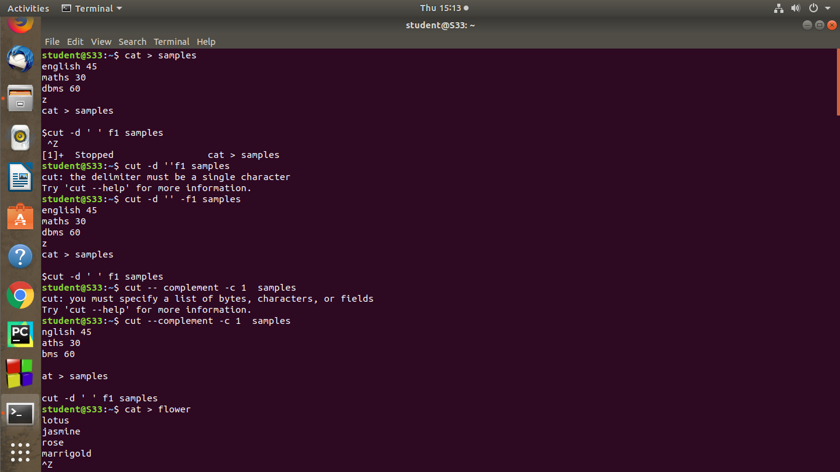

**2. paste -** It is used to join files horizontally (parallel merging) by outputting lines consisting of lines from each file specified, separated by tab as delimiter, to the standard output.

**syntax:**

$paste file1

**output:**

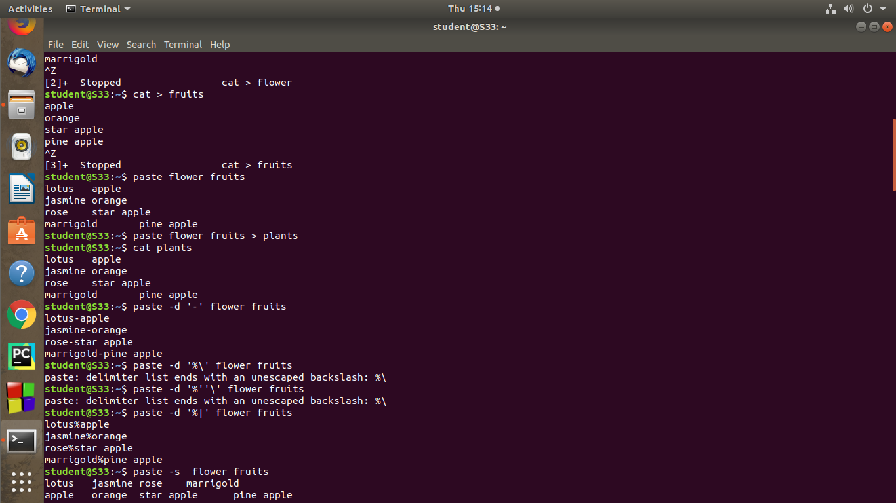

**3. more -** more commands is used to view the text files in the command prompt, displaying one screen at a time in case the file is large. The more command also allows the user do scroll up and down through the page.

**syntax:**

$more file1

**output:**

